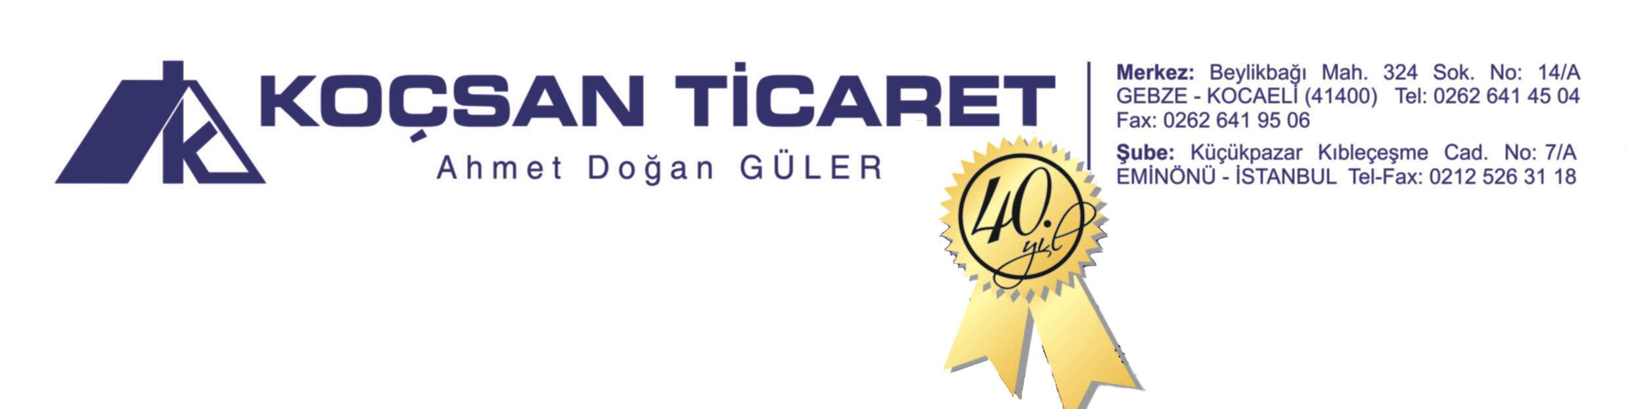

**KOÇSAN TİCARET - AHMET DOĞAN GÜLER**

**DOĞAL ÇAM KATRANI (NATURAL PINE CATEGORY) ANALİZ RAPORU (ANALYSIS REPORT)**

**20.01.2017**

BOILING POINT : 110 degC

GRAVITY : 1.02-1.08

FLASH POINT : 95 degC

VISCOSITY : 200-210 CP(50degC)

ASH : 0,3 %(weight)

ASID NO : 79

SHELF LIFE : 2 YIL